spec

1 Introduction 5
2 System Specification 5
2.1 High Level System Architecture Diagram 5
2.2 Hardware Specification and Server Configuration 5
2.2.1 Development Environment 5
2.2.2 Test Environment 5
2.2.3 Production Environment 5
2.3 Software Specification 5
2.4 System Interfaces or 3rd Party Products 6
2.4.1 SAP 6
2.4.2 Master Data Management 6
2.5 Security 6
2.5.1 Authentication 6
2.5.2 Authorisation 6
2.6 Development Standards & Compliance 7
2.7 Configuration Management 7
2.8 Testing Strategy 7
2.8.1 Unit Testing 7
2.8.2 System Integration Testing 7
2.8.3 Performance Testing 7
2.8.4 User Acceptance Testing 7
2.8.5 Backup & Recovery 7
3 User Interface Specification 8
3.1 Menu and Navigation Overview 8
3.2 Functional Requirements – High Level Overview 8
3.2.1 Overview 8
3.2.2 General Requirements 9
3.3 Validation 9
3.4 Style Sheets 9
3.5 Functions 9
3.6 Database Objects 9
3.7 Templates 9
3.8 Screen Mock-ups 10
3.9 Screen resolutions 10
3.10 Page Weights 10
3.11 Any Other Multimedia Objects 10
3.12 User Agent specification 10
3.13 User Interface Design and Development 10
4 Technical Design 11
4.1 Application Design 11
4.2 Database Design 11
4.2.1 Entities 11
4.2.2 Entity Relationship of Containers 12
5 Integration 16
5.1 Third Party relationships 16
6 Risks, Issues, Assumptions and Dependencies 16
6.1 Risks 16
6.2 Issues 16
6.3 Assumptions 17
6.4 Dependencies 17
7 Appendices 17

Introduction
This document describes the underlying technology of the Web Application for the Packaging Material Database to be delivered to Siegwerk Druckfarben AG & CO. KGaA.
The Web Application will be developed by a third party supplier to WCFSmart, and this document is the basis for a binding formal offer by the supplier.
This Web Application is a standalone with its own underlying database and its purpose is to allow selected employees of Siegwerk Druckfarben AG & CO. KGaA to maintain a database of packaging material and related certificates, including a download facility where product fact sheets can be downloaded in PDF format.

System Specification
The application is designed as a classic 3-Tier Architecture, with Web-, Service- and Persistence-Layers.

High Level System Architecture Diagram
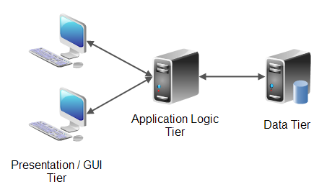

Hardware Specification and Server Configuration

Development Environment
There is no specification, the developers are responsible for their own development environment specification and setup.

Test Environment
The web application will run on the following hardware:
- Ubuntu 14.04 LTS and higher
- 1 CPU with 4 cores
- 8 GB RAM

Production Environment
The web application will run on the following hardware:
- Ubuntu 14.04 LTS and higher
- 1 CPU with 4 cores
- 8 GB RAM

Software Specification
The application is written using Java/JEE, and runs in a Tomcat v7 Servlet Container, connecting to an Oracle 11g database, which are both hosted on Linux (Ubuntu 14) operating systems.

The web application is developed with the following mark-up, style-sheet and programing languages and their respective versions:
- HTML 4.01 or 5.0
- CSS 3
- JavaScript 1.8.2
- Java 6

The web application is developed with the following frameworks and their respective versions:
- JEE 7
- Standard JDBC or JPA
- Apache Maven 3.3
- Springframework 4.0.2
- Apache Commons
- JSTL and/or Spring’s TLDs
- Slf4J and Log4J
- TestNG, Mockito
- AngularJS and/or jQuery

The following server versions need to be supported:
- Apache Tomcat 7.0.52
- Oracle Database 11g Release 11.2.0.4.0 - 64bit Production

System Interfaces or 3rd Party Products
There are two system interfaces, but our current understanding is that these are not necessarily in scope, as they are nice-to-haves, therefore we declare them out-of-scope. Nevertheless, we briefly mention them here for the sake of completeness…

SAP
The SAP interface would be used by the web application to create a new VPS number in the relevant SAP instance and accordingly reference any new packaging material item that is created in the Web Application.

Master Data Management
This interface is used to link non-SAP locations with SAP locations, and it has been specified as a database link with write-credentials to an existing MS SQL Server Database, however we would recommend a Web Service approach, e.g. RESTful.

Security
The data held in this application is not subject to specific data confidentiality or data integrity constraints, other than that it needs to comply with Germany’s Federal Data Protection Act (Bundesdatenschutzgesetz or BDSG).
Nevertheless, the protocol used is HTTPS (HTTP over TLS).
The following certificate will be used:
WcfSmart issued by Thawte, Inc. (expires 18 January 2019),
Serial Number: 2C:DC:3B:B7:73:A4:4F:B6:DD:62:FD:B0:4C:8F:10:41

Authentication
Access to the web application is controlled by username/password-based authentication via an HTML form in a friendly login-page. The web application also requires a logout button/link.
Usernames and passwords are stored in the database, encryption requirements for passwords TBD.
The user session should end after an inactivity period of 30 minutes.

Authorisation
There are three user roles in this web application:
- Reader
- Writer
- Admin

The below authorisation matrix shows the entitlements by role:
Global Processes | Reader | Writer | Admin
Read/Download Content | x | x | x
Create/Upload Content |  | x | x
Modify Content |  | x | x
Delete Content |  |  | x
Approve Content Modifications |  |  | x
Manage Users |  |  | x

Development Standards & Compliance
- The Java aspect of the web application is built complying with source code conventions according to https://google.github.io/styleguide/javaguide.html.
- Wherever logic is implemented in Java this is developed by use of unit tests. This will mainly apply to the Services as the design defines that this is where logic resides. We would expect a reasonably high unit test coverage (in the region of 80 %, TBC).
- The web application is designed as an Apache Maven project with maven-archetype-webapp archetype, and should otherwise use Maven’s standard directory structure and conventions. Apart form the usual directory structure, SQL DDL and DML scripts are stored in the following location: src/main/resources/sql.
- Otherwise the web application should conform with the JSE and JEE standards and best practices in terms of directory structures and naming conventions.
- The web application is designed using Spring MVC with a mainly annotation-based application context configuration.
- Whenever explicit SQL statements are used in the application, these should adhere to Standard SQL, no vendor-specific Query Language (e.g. Oracle’s P/L SQL) or dialects (e.g. DECODE) are used.
- For the presentation layer in HTML the following style guidelines are adhered to http://www.w3schools.com/html/html5_syntax.asp, using lower-case tags throughout.
- In order to keep exposure to different web-browser implementations and versions to a minimum JavaScript is used sparingly.
- Internationalisation is achieved by use of Java properties file resource bundles for the application structure. This includes currencies, time and date formats, floating point numbers, etc.. The application must be able to correctly handle different input formats, e.g. decimal points (“,” vs. “.”). The content is held in several languages in the database. This needs to be taken into account for the database design.

Configuration Management
The code for this web application is version controlled using GIT. The repository is hosted on one of WCFSmart’s own servers, the supplier’s developers will be granted access to only that server via VPN.
The branching strategy is to be confirmed. This is not critical at this stage.

Testing Strategy

Unit Testing
To be performed by the developers.
Dependency: None.
Exit Criterion: All unit tests pass.

System Integration Testing
To be performed by the developers.
Dependency: Successful Pass of Unit Testing.
Exit Criterion: The system runs stable throughout the whole process flow and meets the non-functional requirements (TBD).

Performance Testing
To be performed by the developers.
Dependency: Successful Pass of System Integration Testing.
Exit Criterion: The system runs performant flow and meets the non-functional requirements (TBD). Performance requirements TBD.

User Acceptance Testing
To be performed by the users.
Dependency: Successful Pass of Performance Testing.
Exit Criterion: The system meets the functional requirements.

Backup & Recovery
The standard Linux backup and recovery mechanism currently applied to our own server landscape will suffice.

User Interface Specification

Menu and Navigation Overview
- Home/Start Page
- Global Processes & Information
  - Global Processes
  - Global Information
- Containers
- Suppliers
- Administration

Functional Requirements – High Level Overview
The embedded spreadsheets specify the input forms and their fields:
The following document specifies the functional requirements:
Lastenheft.pdf

Overview
Home/Start Page (Lastenheft.pdf Section 5.2)
The Entry Point, contains Information and News, its content is to be manageable by Admins.

Global Processes & Information (Lastenheft.pdf Section 5.3)
Global Processes (Lastenheft.pdf Section 5.3.1)
A document repository, a facility to upload and download documents. Mime types TBD.
Global Information (Lastenheft.pdf Section 5.3.1)
Functionally identical to Global Processes, just only for Global Information. Technically there is no difference.

Container (Lastenheft.pdf Section 5.4)
Describes a packaging unit for the company’s products. Whenever a record is modified an email is sent to the administrator(s).
Container Overview (Lastenheft.pdf Section 5.4.1)
Lists all containers, with a details view by product via button/link click. Containers must be linked to their relevant certificates.
Container Entry (Lastenheft.pdf Section 5.4.2)
Allows for entry of a new container via button click. Provides container categories via a select input. Input fields are driven by container category.
Container Modification (Lastenheft.pdf Section 5.4.3)
Allows for modification of an existing container via button click. Provides the same form as the Container Entry.
Container Deletion (Lastenheft.pdf Section 5.4.4)
Allows for deletion of an existing container via button click.
Container Product Details Export (Lastenheft.pdf Section 5.4.5)
Allows for export/download of an existing container via button click. Provides two different templates, one for Sales (Business Unit?) and one for Supplier Chain Management. The use of template is driven by user role (Sales or SCM).

Suppliers (Lastenheft.pdf Section 5.5)
Allows maintenance of containers-to-supplier-to-certificates references. It provides tree-like access to a supplier’s containers and certificates.

Administration (Lastenheft.pdf Section 5.7)
Allows for User Maintenance and Home/Start Page Maintenance, and Approval of Modifications of Containers (i.e. Four-Eyes-Principle).

General Requirements
- The Start/Home Page is maintainable by Administrators (Content Management).
- Administrators are notified via email whenever a modification of content was performed by a user with Writer role.
- The PDF download is based on templates per container category, and also by the user’s business area (BU/Sales vs. SCM). The latter must be driven by and attributable to the user account.
- The following languages must be supported by the web application:
- English
- German
It must be possible to add further languages in the future.

Validation
Numeric values, dates, email addresses, file formats, etc. are subject to type/format validation, with form submission only ever occurring with valid parameters. Mandatory fields also need to be included.

Style Sheets
The branding of the user interface is entirely flexible in the sense that all formatting is controlled by use of cascading style sheets (CSS). Web views should only reference the relevant CSS classes, and contain no overriding formatting.
Logos, and the following corporate colours are to be used:
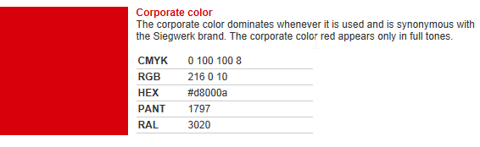

Functions
Form input fields for dates should comprise a date picker. Data referenced by foreign keys is accessible via HTML links.
Besides full text search, a column-specific search by the following criteria is implemented:
- Starts with
- Ends with
- Contains
- Is
- More Than
- Less Than
- Foreign Key

Database Objects
For each primary key a sequence mechanism is used to ensure the use of unique identifiers. Neither Triggers nor Procedural SQL are used.

Templates
HTML Framesets and frames must not be used, frame-like structures are to be implemented by use of CSS and HTML div elements.
The following templates are reasonable to consider:
- Header
- Menu
- Footer
- Content
The different types of content templates are:
- Start/Home View
- Start/Home Modification
- Global Processes/Information Upload
- Global Processes/Information View (includes Download)
- Container Listing (Table) View
- Container Creation/Modification/Approval (for currently 8 different container categories based on a dropdown selection)
- Container Detail View (includes Deletion and Download, Attachments)
- Supplier Creation/Modification/Approval
- Supplier Detail View
- User Listing (Table) View
- User Creation/Modification

Screen Mock-ups
Due to the simplicity of this application no screen mock-ups will be produced.

Screen resolutions
The web application is optimised for a screen resolution of 1024 x 768 pixels and higher, and 24-bit colour depth.
The aspect ratio of all site components are maintained at all reasonable web-browser window sizes.

Page Weights
Page weights are to be held as low as possible. Metrics TBD.

Any Other Multimedia Objects
File formats to be uploaded TBD.
No other multimedia objects like Videos will be used.

User Agent specification
The web application is accessed via web-browsers. It will support the following web-browser versions:
- Mozilla Firefox 38 (ESR) and above
- Google Chrome 40 and above
- Internet Explorer 11.0
There are no restrictions as to the operating systems from which these web-browsers are initiated, nor should the application depend on any web-browser plugins or add-ons (e.g. Shockwave Flash).

User Interface Design and Development
The user interface is designed with a combination of Java Server Pages, HTML, CSS, JavaScript.

Technical Design

Application Design
The application is designed as a classic 3-Tier Architecture, with Web-, Service- and Persistence-Layers, using Spring MVC for the former two. The persistence Layer can be implemented using plain JDBC or JPA.
The below diagram describes the generic Spring MVC processing flow:

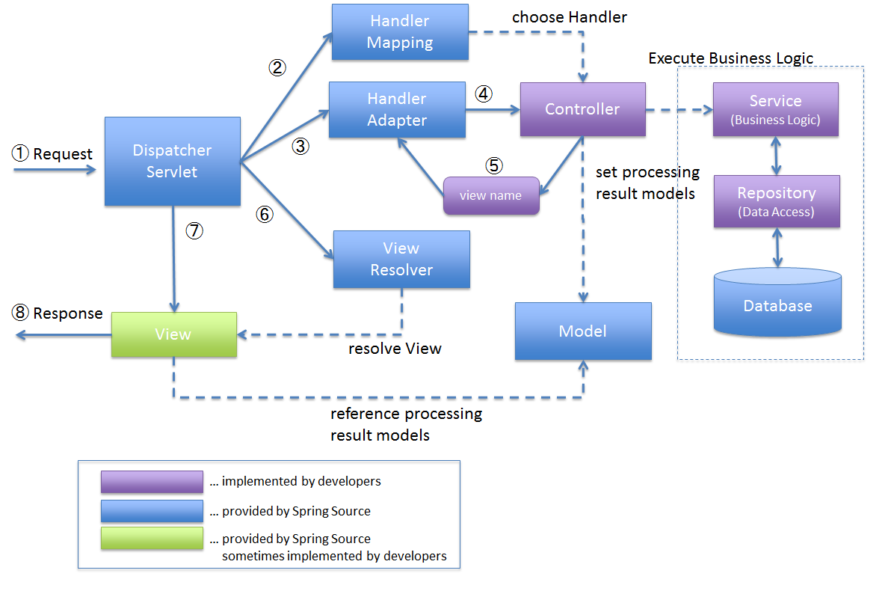
Database Design

Entities
- ADDRESS
- ADDRESS_TYPE
- BUSINESS_UNIT
- COATING
- COATING_TYPE
- CONTAINER
- CONTAINER_CATEGORY
- CONTAINER_TYPE
- COUPLING
- COUPLING_TYPE
- DESIGN
- DOWNLOAD_TEMPLATE
- EX_ZONE
- GASKET
- HANDLE
- LANGUAGE
- LEGAL_ENTITY
- LEGAL_ENTITY_TYPE
- LOCATION
- MATERIAL
- MATERIAL_TYPE
- PALETTE_TYPE
- SEAL
- SEAL_TYPE
- STATUS
- TRANSPORTATION
- UN_APPROVAL
- UN_ASSIMILATION_LIST
- UN_PACKAGING_INSTRUCTION
- UN_TEST_MEDIUM
- UN_TRANSPORT
- UNIT
- USER
- USER_ENTITLEMENT
- USER_ROLE

Entity Relationship of Containers
The following section specifies the database design for containers:

ERD-BigBags.pdf

ERD-Dosen_Konisch.pdf

ERD-IBC_Kubisch.pdf

ERD-IBC_Schuettgut.pdf

ERD-IBC_Zylindrisch.pdf

ERD-Kanister_Kubisch.pdf

ERD-Spannring_Konisch.pdf

ERD-Spannring_Zylindrisch.pdf

Integration

Third Party relationships
There are no significant third party dependencies that will require coordination with regard to technology. The following parties are generally involved in this project:
Party | Role
Siegwerk Druckfarben AG & CO. KGaA | Application User, tests and uses the software.
WCFSmart | Application Service Provider, hosts and maintains the web application and database schema on its server stack, is the overall coordinator of this project.
The Supplier TBD | Application Supplier, delivers the software for this web application.

Risks, Issues, Assumptions and Dependencies

Risks

Issues
- There may be significantly more entities and foreign-key references involved in a clear database design compared to what is currently provided in EingabemaskenGebinde_Referenzen.xls, e.g. ADDRESS or TRANSPORTATION. Most of the restrictive fields are free form text rather than references, e.g. GASKET.MATERIAL. The database design needs to be reviewed.
- It is not clear at this stage how new containers are added in terms of languages, is it allowed to have an item in one language, but not in every other language, i.e. is there an all-or-nothing constraint, which would mean that an item has to be added in all (currently 2 languages)?

Assumptions
- The System Interfaces with SAP and the Master Data Management are out of scope of delivery and thus this document.
- During the approval of a change to a container (Creation/Modification) an Administrator should not have the right to further modify that change, but to only accept/reject.
- An audit trail facility to track change history is not required.
- The number of languages to be supported will not change in the course of this project.
- A Certificate is an attribute of a container.

3. Beschreibung des Soll-Konzepts
3.1 Systemumgebung
Die neue Applikation soll über SharePoint 2013 Foundation aufgerufen werden können. Die
Applikation soll als moderne SharePoint-App zur Verfügung gestellt werden, die Ihre Daten
aus einer SharePoint unabhängigen und relationalen MS-SQL Datenbank abrufen soll. Nach
der Entwicklung der Datenbank soll diese auf ein bestehendes SQL-Cluster installiert
werden.

